Arrange even row elements in ascending and odd row in descending order
#include<stdio.h>
#include<conio.h>
void main()
{
int a[10][10],nr,nc,r,c,i,j; clrscr();
printf("Enter no of rows and columns "); scanf("%d %d",&nr,&nc);
printf("Enter %d elements \n",nr*nc);
for(r=0;r<nr;r++)for(c=0;c<nc;c++)
scanf("%d",&a[r][c]);
for(r=0;r<nr;r++)
{
for(i=0;i<=nc-2;i++)
{
for(j=i+1; j<=nc-1;j++)
{
if(r%2==0)
{
if(a[r][i]>a[r][j]){int t=a[r][i];a[r][i]=a[r][j];a[r][j]=t;}}
else
{ if(a[r][i]<a[r][j]) {int t=a[r][i];a[r][i]=a[r][j];a[r][j]=t;}}
} }
}
puts("Sorted elements");
for(r=0;r<nr;r++)
{
for(c=0;c<nc;c++)printf("%4d",a[r][c]);
printf("\n");
}
getch();
}
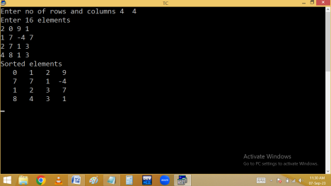Eg. Finding fractions of n*n matrix:
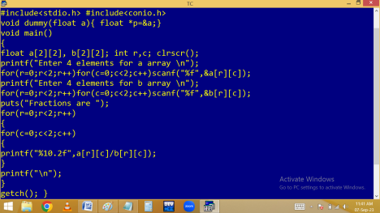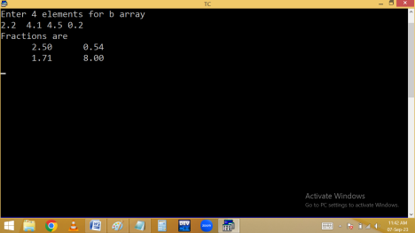
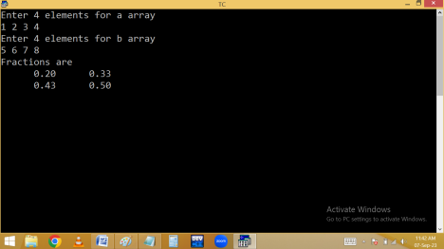Matrix multiplication:
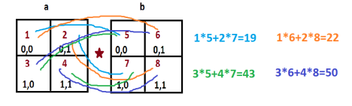
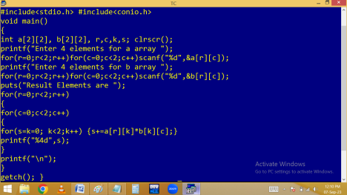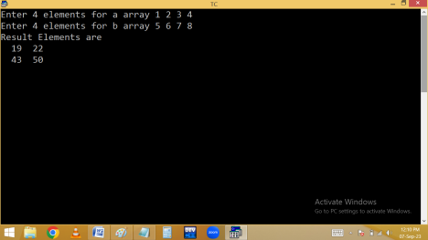
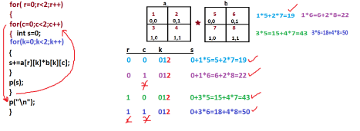3-dimensional arrays:
An array with several blocks, rows and columns. An array with 3 subscripting operators [ ] [ ] [ ]. Syntax:
datatype variable [ blocks ] [ rows ] [ columns ];
Eg: int a[2][2][2]={1,2,3,4,5,6,7,8};
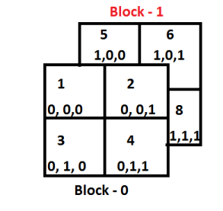Eg:
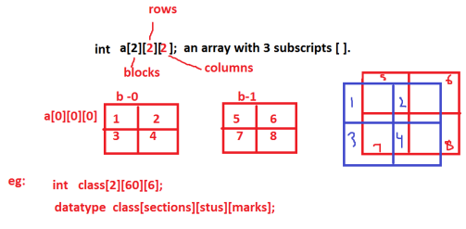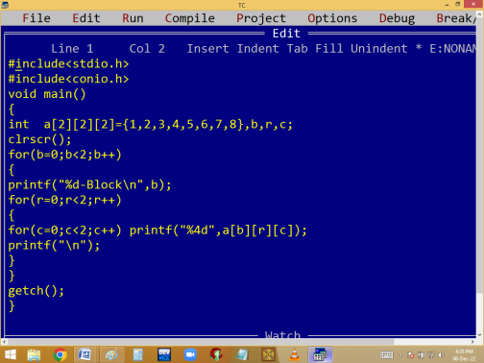
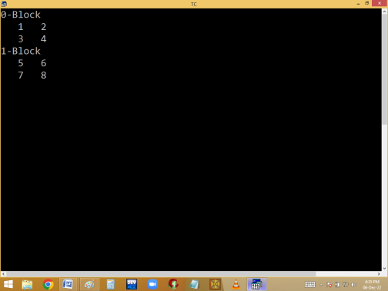
4-dimensional array:
An array with several sets, blocks, rows and columns.
An array with 4 subscripting operators [ ] [ ] [ ] [ ] .
Syntax:
datatype variable [ sets ] [ blocks ] [ rows ] [ cols ];
eg:
int a[2] [2] [2] [2]= {1,2,3,4,5,6,7,8,9,10,11,12,13,14,15,16};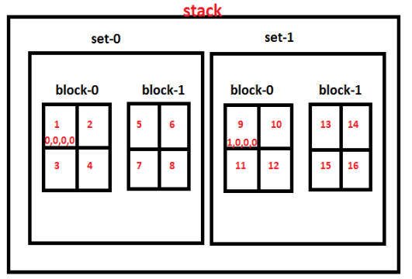
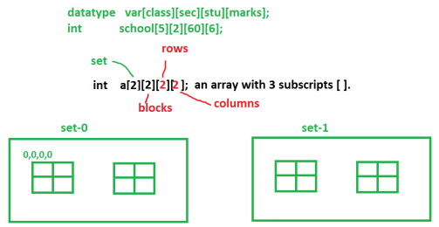
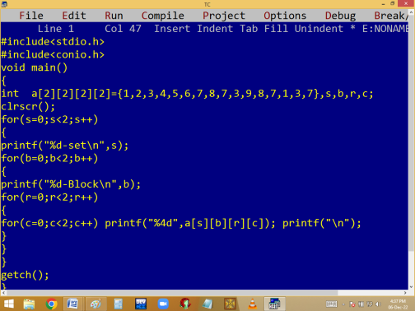
STRINGS
∙ A group of characters is called string.
∙ It is one dimensional character array. ∙ It is alpha-numeric.
∙ It is an implicit pointer.
∙ It is a derived data type.
Note:
∙ One byte should be left for Null char( \0 ). Otherwise we are getting garbage or junk values. Null char indicates string is completed.
∙ String variable Size can’t be less than string. Otherwise we are getting error. ∙ Using = operator, we can’t copy a string into another. We have to use strcpy() or copy character by character manually. ∙ Using == (comparison) operator, we can’t compare two strings. Use strcmp() or compare the characters one by one manually.
Syntax:
char variable [size] = “string”;
or
char variable[ ]=”string”;
Eg: char st[5] = “Rama”;
Note: String is implicit pointer because of string variable stores base address.
String declaration methods:
char st [5] =”rama”; Ok
char st [20] =” Naresh It”; Ok
char st [4] = { ‘r’, ‘a’, ‘m’ }; Ok 🡪 char array.
char st[3]= “ram”; It gives garbage values in printing.
char st [3] = “rama”; error
char st[0]; error
char st[0]=”abc”; Ok
char st[-5]; error
char st[5.5]; error
char st[5%3]; Ok 🡺 char st[2]; char st[3+2]; 🡺 st[5] 🡺 Ok
char st[ ] =”Ram”; Ok.
char st[ ] ; error
int n=20;
char st[n]; No
#define n 20
char st[n]; Ok
Note: String variable size always constant positive integer value.

